Latest Round-ups:
Season 2019/20
#24
Midweek Action: Plymouth Parkway took ownership of top spot in the Premier Division on Tuesday evening following a 3-0 win away at Keynsham Town. Leading scorer Adam Carter led the way for the visitors, striking twice during the first half, with Mikey Williams then completing the scoring after the interval. Elsewhere that night, a fast start from Bridgwater Town propelled them to a 4-0 victory over Cadbury Heath. The hosts took less than two minutes to break the deadlock, with David O’Hare powering home a Sam Towler corner. Noah Coppin then doubled the lead in the 26th minute, with further goals coming from Jack Taylor and Jake Llewellyn during a quiet second half. At the Tannery Ground, Street’s Callum Thompson struck at the end of the first half to condemn Odd Down to a 1-0 defeat.

Ashton & Backwell are one of the form sides in the First Division, and they stretched their run of victories to four matches on Tuesday night, with Calum Townsend’s brace helping them beat Welton Rovers 2-1. Townsend struck in either half to put the Stags in control, with Welton falling just short of a comeback despite Tom Lakeman’s excellent finish seven minutes from time. At Lakeview, goals from James Vincent and Harry Barnes weren’t enough for Warminster to gain all three points, with Town having to settle for a 2-2 draw against a resurgent Bishop Sutton outfit.

Exmouth Town will travel to take on Bridgwater in the quarter-finals of the Les Phillips Cup after sneaking past Shepton Mallet by two goals to one. Having taken a 35th minute lead through Callum Shipton, Exmouth saw their advantage cancelled out when Tyrone Tucker-Dixon scored for the second consecutive fixture for Shepton. The Devon side scored the third and final goal against the run of play, with Aaron Denny finding the back of the net 15 minutes from time. In the Gloucestershire FA Challenge Trophy, Bitton romped to a 6-0 victory away at Almondsbury, with Harrison Kyte scoring twice during a one-sided second half display which saw the away side score five times. 24 hours later, Bristol Telephones were also in stunning form in front of goal, putting eight past Brimscombe & Thrupp to book their spot in the third round. Ali Boyer notched a hat-trick for the home side, with Dhani Golding, Keiron Golding, Ben Griffiths and Dawid Regula also scoring during a confidence-boosting 8-3 victory for the Phones.
Concussion Guidelines
The FA have issued guidelines on how to deal with players who may have suffered a concussion. The document, which is linked below, has been sent to all clubs. http://toolstationleague.com/downloads/concussion.pdf

FA Vase: Plymouth Parkway were one on three Western League sides to book their spot in the last 16 of the FA Vase, edging past Woodbridge Town by one goal to nil in Suffolk. In what was a tight contest, the all-important goal came 15 minutes from time for the visitors, with a pair of usual suspects linking up. The league’s top scorer Adam Carter is having a prolific season, and he turned provider on this occasion, producing some good play down the right-hand side before crossing for Mikey Williams who slotted the ball home. Parkway will be joined in the next round by joint league-leaders Bradford Town who secured a hard-fought 2-1 win away at Buckland Athletic. The Bobcats made a strong start to the game, and took a 15th minute lead when Dean Griffiths headed home a Jamie Lyons cross. Buckland regrouped at the break, and the Devon side were soon on level terms thanks to a goal from Nathan Cooper. Parity didn’t last long however, and within a minute of losing their lead, Bradford went back in-front, with Gary Higdon crossing for Charlie Maddison who finished well. The final half hour went past without Buckland managing to equalising, meaning Bradford would be the side to progress. In the other all-Western League tie, Bitton came from behind to defeat First Division Warminster 3-1. Having already shocked a number of sides on their way through to the fourth round, Warminster took a surprise lead at the interval and were 45 minutes from a historic victory. Bitton came alive in the final 20 minutes however, and after a stunning finish from Joe McLennan had brought them level, Josh Egan produced a low driven effort which found its way into the visitors net. With Warminster doing everything within their capability to draw level, Bitton took advantage, scoring a third in the closing stages when Harrison Kyte beat the keeper after being sent through one-on-one.
Premier Division: Shepton Mallet have now won six of their last seven in the league, and are up to fourth spot after coming from behind to beat Bridgwater Town 2-1. It was Town who took the lead at Fairfax Park, with David O’Hare scoring after 20 minutes to set his team up for a third consecutive home win. However, Shepton are full of confidence right now, and they managed to bring the game level midway through the second half when Nathan Legge scored his first for the club after being slipped in by Craig Loxton. With their tails up, the away side kept up the pressure, and following a driven cross from Asa White, the ball eventually fell to Daryl Charman who scrambled the ball home from close range to complete the turnaround. At the opposite end of the table, Chipping Sodbury rebounded from last week’s heavy defeat by claiming a 3-1 win at home to Wellington. Both teams started the day in the bottom three, and it was Wellington who looked set to climb the table after Harry Hamblin had given them a 23rd minute lead. With less than a quarter of the game remaining, the Sods were still trailing, but managed to produce an excellent 20 minutes to turn the game on its head. Luke Burnham was the first to break through, with a 25-yard drive levelling affairs, before Jack Moore gave them the lead a couple of moments later. With time running out, Chipping Sodbury added a late third through Jack Parker to give them three home wins on the bounce in all competitions.
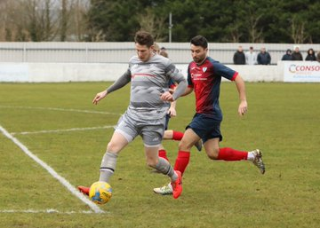
In Bath, Westbury United made it back-to-back away wins to start the new year, after a quick-fire double from Callum Demkiv saw them beat basement-boys Odd Down 2-0. Street’s encouraging start to 2020 continued away at Cribbs, where they gained revenge on a defeat to the same opponents earlier this season by winning 4-2 at the Lawns. The visitors won both halves by two goals to one, with Callum Thompson following up his midweek winner with a goalscoring brace. Kameron Andrews and Oli Hebbard also scored for the Somerset side, with Cory Simpson pulling a goal back for Cribbs who have now incredibly lost 4-2 in all three of their fixtures since Boxing Day. Third-place Exmouth Town defeated Roman Glass St George 2-1 thanks to first half goals from James Richards and Jordan Harris, while a 30th minute effort from Jordan Annear led Tavistock to a 1-0 win away at Bridport.
Action from Westbury’s 2-0 home victory over Odd Down, courtesy of Martin Pearce.
First Division: An equaliser five minutes from time helped preserve Longwell Green’s position atop the First Division table. Taking on one of the most potent attack’s in the division in Bishops Lydeard, Longwell Green found themselves in trouble at the break, falling 2-0 down to goals from Ryan Andrews and Jason Quick. The league leaders were fortunate to keep the deficit at two during the second half, but they showed the fight required for a promotion battle, scoring twice through Sam Crumb and Luke Bryan in the final 25 minutes to claim a hard-fought 2-2 draw at Cothelstone Road. Calne Town were the only side in the top half to claim three points on Saturday afternoon, enjoying a relatively simple 3-0 win away at Oldland Abbotonians. The game was only 11 minutes long when Calne moved into a two-goal lead, with the strike duo of Stuart Windsor and Jamal Chevolleau both finding the back of the net. Oldland were unable to break down their visitors, and eventually fell to a three-goal defeat when Chevolleau smashed home his second of the afternoon in the early stages of the second half. Cheddar fell to a heavy 4-0 defeat away at Welton Rovers who ended their five-match winless run thanks to a rampant second-half. There was only one goal to separate the sides at the break, with a sweet clipped finish from Liam Evans putting the hosts ahead on the half hour. Great perseverance from Tom Lakeman saw him double Welton’s advantage, with Harry Barter and Mickey Parsons also scoring during the final 20 minutes to cap an excellent afternoon for the Green Army.

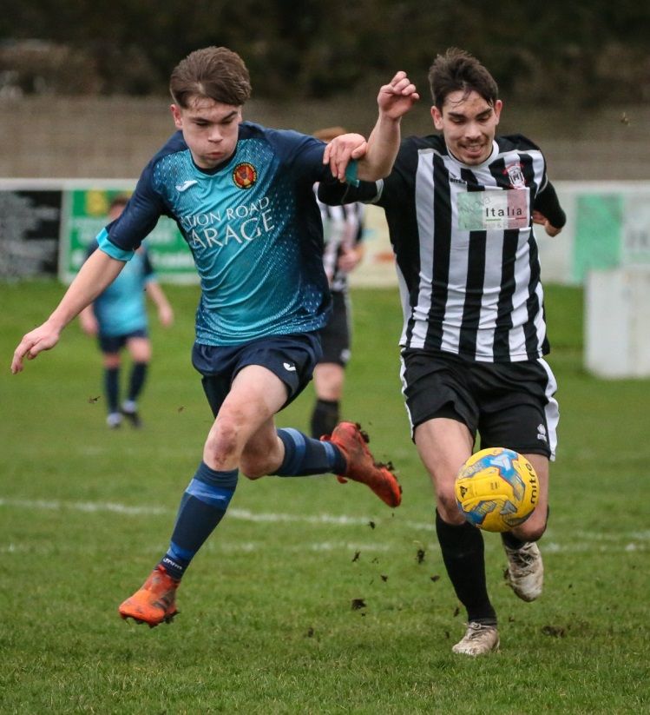
In a top-half battle at Raleigh Grove, Corsham struck late to secure a 1-1 draw away at Sherborne. In-form forward Alex Murphy broke the deadlock for the Zebras two minutes before the interval, but they were denied at the last when Jon Bazley headed home an equaliser five minutes from time following a Corey Harbour-Burgess free-kick. There was also a 1-1 draw between Portishead and Wells, where both teams ended the game with ten-men. It was the hosts who were short-handed first, with Harry Foster’s acrobatic finish punishing them soon after to give Wells the lead. Portishead fought back, and managed to level affairs 20 minutes from time with Nathan Trueman poking the ball home at the back stick following a long free-kick into the box from Mitch Osmond. There was also a 1-1 draw at the Lancer Scott Stadium, where Devizes striker Oscar Webster struck at the end of the first half to cancel out Harry Walker’s 10th minute opener for Ashton & Backwell. Hengrove Athletic have now won four of their last five, after a first-half double from Jack Jones helped lead them to a 3-0 home victory against Bishop Sutton.
Action from the 1-1 draw between Corsham and Sherborne, courtesy of John Cuthbertson.

Western League Scoring Leaders
*All goalscoring stats via Full-Time FA website

PREMIER DIVISION LEADING GOAL SCORERS (League only):
Adam Carter (Plymouth Parkway) – 26
Jordan Harris (Exmouth Town) – 16
Jack Fillingham (Shepton Mallet) – 15
Leighton Thomas (Street) – 14

FIRST DIVISION LEADING GOAL SCORERS (League only):
James Rustell (Radstock Town) – 18
Harry Foster (Wells City) – 18
Stuart Windsor (Calne Town) – 13
Alex Murphy (Sherborne Town) – 12

LEADING SCORERS IN ALL COMPETITIONS:
Jack Crago (Tavistock) - 28
Adam Carter (Plymouth Parkway) – 26
James Rustell (Radstock Town) – 23
Harry Foster (Wells City) – 23
Latest Results
Tuesday 7th January 2020
Premier Division
Bridgwater Town 4-0 Cadbury Heath 131
Keynsham Town 0-3 Plymouth Parkway 147
Street 1-0 Odd Down 61
First Division
Bishop Sutton 2-2 Warminster Town 39
Welton Rovers 1-2 Ashton & Backwell United 58
Les Phillips Cup – Second Round
Shepton Mallet 1-2 Exmouth Town
GFA Challenge Trophy – Second Round
Almondsbury 0-6 Bitton 35
Wednesday 8th January 2020
GFA Challenge Trophy – Second Round
Bristol Telephones 8-3 Brimscombe & Thrupp 42
Saturday 11th January 2020
FA Vase – Fourth Round
Bitton 3-1 Warminster Town 199
Buckland Athletic 1-2 Bradford Town 174
Woodbridge Town 0-1 Plymouth Parkway
Premier Division
Bridgwater Town 1-2 Shepton Mallet 302
Bridport 0-1 Tavistock 91
Chipping Sodbury Town 3-1 Wellington 75
Cribbs 2-4 Street 72
Exmouth Town 2-1 Roman Glass St George
Odd Down 0-2 Westbury United 62
First Division
Ashton & Backwell United 1-1 Devizes Town
Bishops Lydeard 2-2 Longwell Green Sports 35
Hengrove Athletic 3-0 Bishop Sutton
Oldland Abbotonians 0-3 Calne Town 31
Portishead Town 1-1 Wells City 45
Radstock Town A-A Lebeq United
Sherborne Town 1-1 Corsham Town 77
Welton Rovers 4-0 Cheddar 72
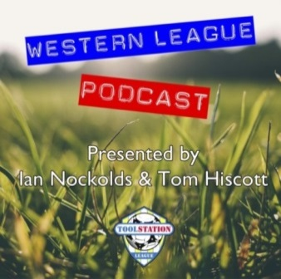

Be sure to check out the latest podcast, where Ian, Tom & guests recap all the latest news and results from around the Western League. To follow along all season, each broadcast will be available at the following link: http://www.toolstationleague.com/podcasts.php

Upcoming Fixtures
Tuesday 14th January 2020
Premier Division
Brislington vs Bitton 19:30KO
Buckland Athletic vs Tavistock 19:30KO
Shepton Mallet vs Cribbs 19:30KO
First Division
Bristol Telephones vs Cheddar 19:45KO
Longwell Green Sports vs Wells City 19:30KO
Portishead Town vs Sherborne Town 19:30KO
Wincanton Town vs Calne Town 19:30KO
Les Phillips Cup – Quarter Final
Bridgwater Town vs Exmouth Town 19:45KO
Wednesday 15th January 2020
Premier Division
Westbury United vs Roman Glass St George 19:30KO
First Division
Oldland Abbotonians vs Bishop Sutton 19:45KO
Warminster Town vs Devizes Town 19:45KO
Devon FA St Lukes Bowl – Second Round
Plymouth Parkway vs Ilfracombe Town 19:45KO
GFA Challenge Trophy – Second Round
Longlevens vs Hallen 19:45KO
Saturday 18th January 2020 (KICK OFF AT 3.00PM UNLESS NOTED)
Premier Division
Bradford Town vs Cadbury Heath
Buckland Athletic vs Bridgwater Town
Chipping Sodbury Town vs Exmouth Town
Hallen vs Clevedon Town
Keynsham Town vs Bridport
Odd Down vs Roman Glass St George
Street vs Shepton Mallet
Wellington vs Bitton
Westbury United vs Tavistock
First Division
Bishop Sutton vs Ashton & Backwell United
Calne Town vs Portishead Town
Cheddar vs Almondsbury
Devizes Town vs Corsham Town 14:00KO
Lebeq United vs Wells City 15:15KO
Oldland Abbotonians vs Bishops Lydeard
Radstock Town vs Bristol Telephones
Sherborne Town vs Hengrove Athletic
Warminster Town vs Longwell Green Sports
Welton Rovers vs Wincanton Town

League Tables
Premier Division
 |  | P | W | D | L | F | A | GD | PTS
1 | Plymouth Parkway | 18 | 15 | 1 | 2 | 67 | 19 | 48 | 46
2 | Bradford Town | 18 | 15 | 1 | 2 | 54 | 18 | 36 | 46
3 | Exmouth Town | 17 | 14 | 1 | 2 | 44 | 14 | 30 | 43
4 | Shepton Mallet | 20 | 12 | 3 | 5 | 48 | 27 | 21 | 39
5 | Hallen | 20 | 12 | 3 | 5 | 44 | 33 | 11 | 39
6 | Clevedon Town | 22 | 12 | 3 | 7 | 48 | 41 | 7 | 39
7 | Tavistock | 17 | 12 | 2 | 3 | 46 | 23 | 23 | 38
8 | Bridgwater Town | 21 | 11 | 4 | 6 | 55 | 32 | 23 | 37
9 | Street | 25 | 10 | 4 | 11 | 54 | 55 | -1 | 34
10 | Bitton | 18 | 10 | 1 | 7 | 47 | 30 | 17 | 31
11 | Westbury United | 22 | 9 | 3 | 10 | 40 | 33 | 7 | 30
12 | Buckland Athletic | 18 | 9 | 1 | 8 | 34 | 35 | -1 | 28
13 | Brislington | 22 | 8 | 3 | 11 | 32 | 54 | -22 | 27
14 | Keynsham Town | 20 | 7 | 3 | 10 | 37 | 44 | -7 | 24
15 | Cribbs | 21 | 7 | 2 | 12 | 33 | 52 | -19 | 23
16 | Cadbury Heath | 23 | 5 | 7 | 11 | 29 | 52 | -23 | 22
17 | Roman Glass St George | 19 | 6 | 3 | 10 | 40 | 28 | 12 | 21
18 | Chipping Sodbury Town | 22 | 5 | 1 | 16 | 28 | 70 | -42 | 16
19 | Bridport | 22 | 4 | 1 | 17 | 27 | 71 | -44 | 13
20 | Wellington | 21 | 3 | 2 | 16 | 22 | 57 | -35 | 11
21 | Odd Down | 21 | 3 | 1 | 17 | 16 | 54 | -38 | 10

First Division
 |  | P | W | D | L | F | A | GD | PTS
1 | Longwell Green Sports | 19 | 12 | 3 | 4 | 50 | 30 | 20 | 39
2 | Calne Town | 18 | 12 | 2 | 4 | 32 | 12 | 20 | 38
3 | Ashton & Backwell United | 20 | 10 | 6 | 4 | 34 | 35 | -1 | 36
4 | Wells City | 18 | 10 | 5 | 3 | 43 | 22 | 21 | 35
5 | Sherborne Town | 19 | 11 | 2 | 6 | 42 | 31 | 11 | 35
6 | Radstock Town | 16 | 11 | 1 | 4 | 44 | 24 | 20 | 34
7 | Corsham Town | 20 | 9 | 3 | 8 | 33 | 43 | -10 | 30
8 | Cheddar | 19 | 8 | 4 | 7 | 33 | 32 | 1 | 28
9 | Wincanton Town | 15 | 8 | 2 | 5 | 30 | 32 | -2 | 26
10 | Oldland Abbotonians | 18 | 7 | 5 | 6 | 22 | 29 | -7 | 26
11 | Warminster Town | 19 | 8 | 1 | 10 | 36 | 27 | 9 | 25
12 | Bishops Lydeard | 17 | 7 | 3 | 7 | 39 | 31 | 8 | 24
13 | Lebeq United | 18 | 8 | 0 | 10 | 39 | 40 | -1 | 24
14 | Welton Rovers | 21 | 6 | 4 | 11 | 26 | 39 | -13 | 22
15 | Hengrove Athletic | 19 | 6 | 4 | 9 | 13 | 37 | -24 | 22
16 | Portishead Town | 18 | 5 | 4 | 9 | 34 | 35 | -1 | 19
17 | Almondsbury | 17 | 5 | 4 | 8 | 24 | 30 | -6 | 19
18 | Devizes Town | 18 | 3 | 6 | 9 | 30 | 38 | -8 | 15
19 | Bishop Sutton | 18 | 3 | 3 | 12 | 23 | 37 | -14 | 12
20 | Bristol Telephones | 19 | 2 | 2 | 15 | 28 | 51 | -23 | 8

